# SBA10

## run Selenium Tests with Jenkins on AWS EC2

Setup EC2 Ubuntu Server on AWS

1. Open AWS Management Console and search for EC2 instance

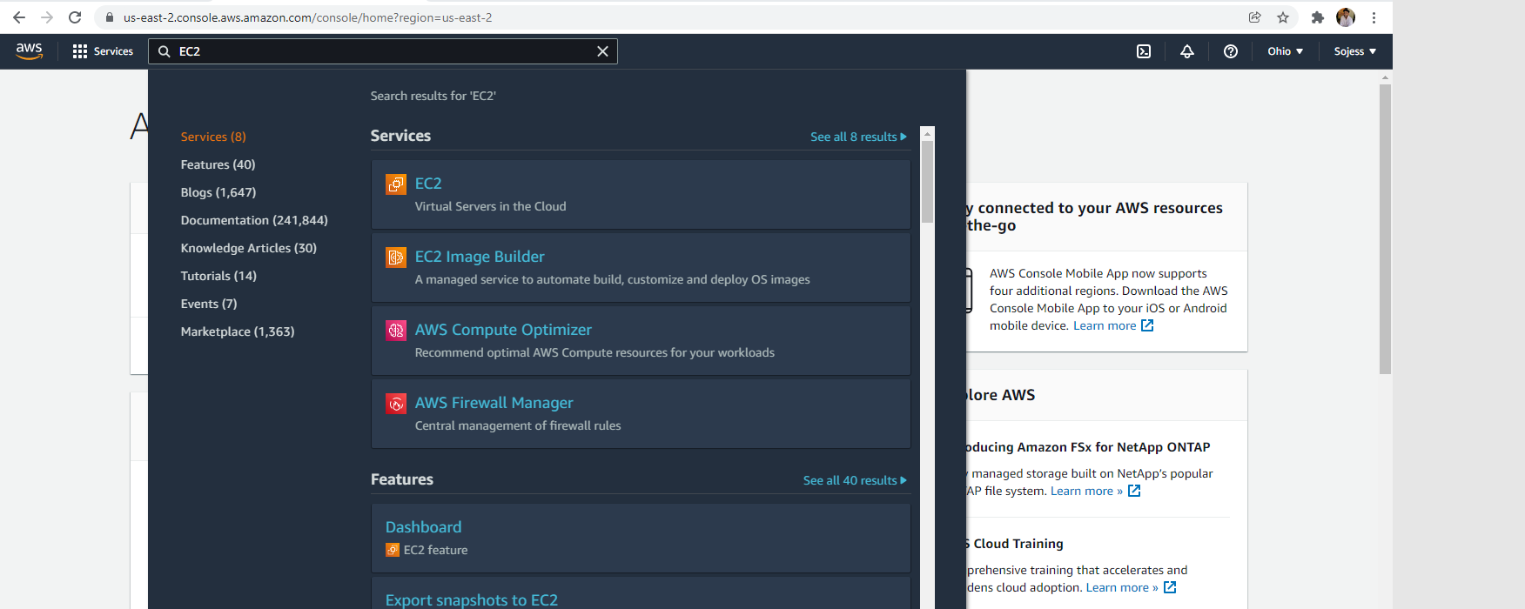

1. Select EC2 and click on launch instances

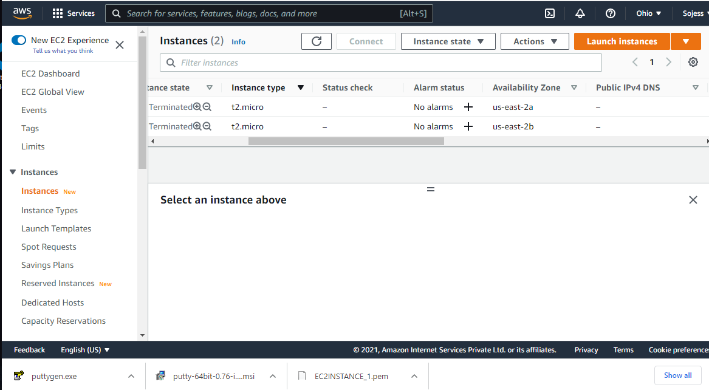

1. Select Ubuntu 20.04 LTS from the list

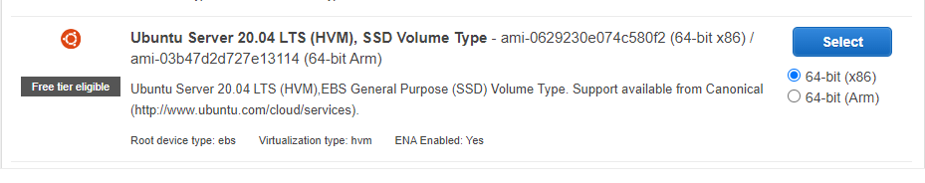

1. Select t2 micro “free tier eligible” from the list and click on Next

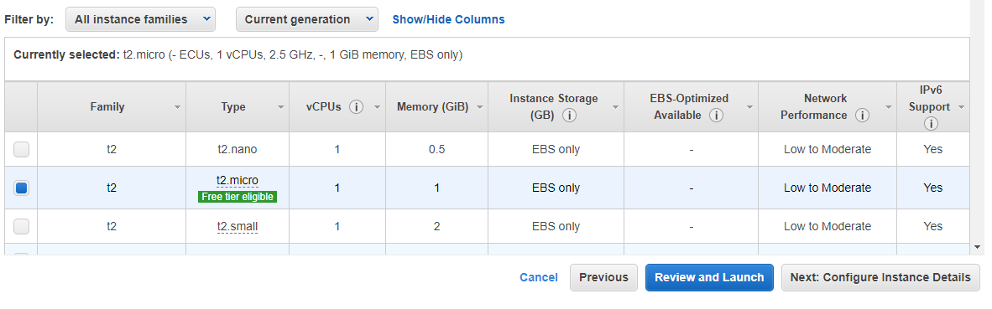

1. Click Next until step 6

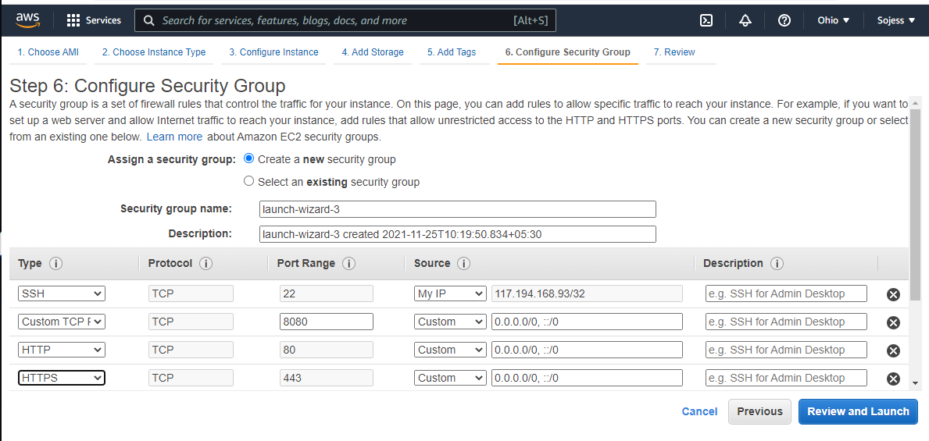

1. Add these rules to the section and click on Review and Launch

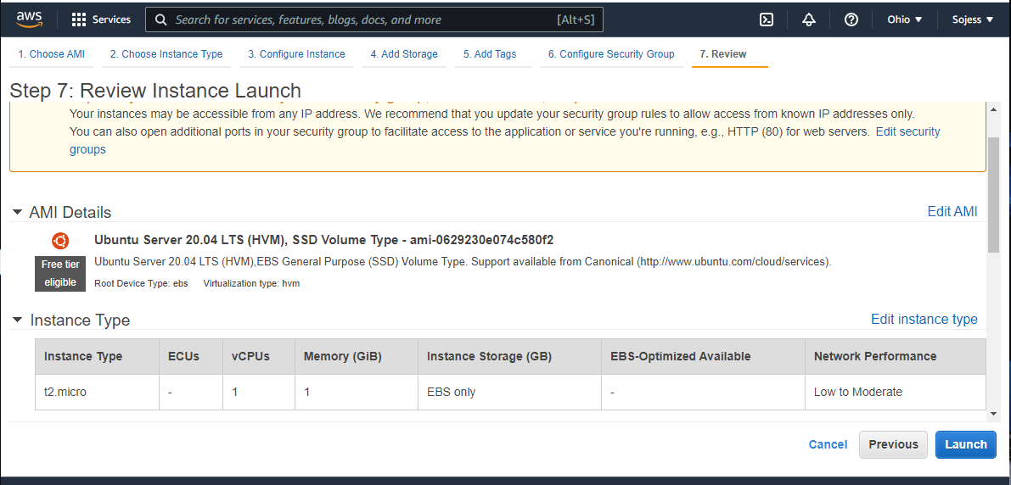

1. Click on Launch

c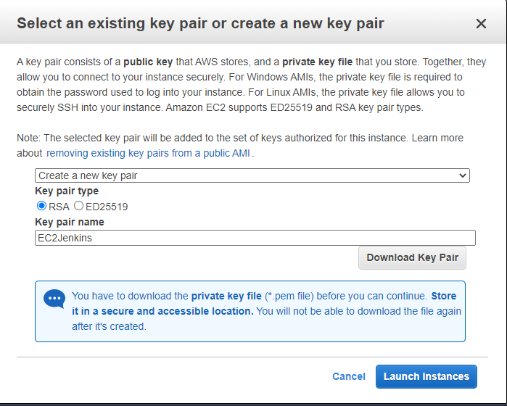

1. Select “Create a new key pair” from the drop down and give a name to the key pair, then click on ”Download Key Pair” then click on Launch Instances.
2. Your instance will be up and running.

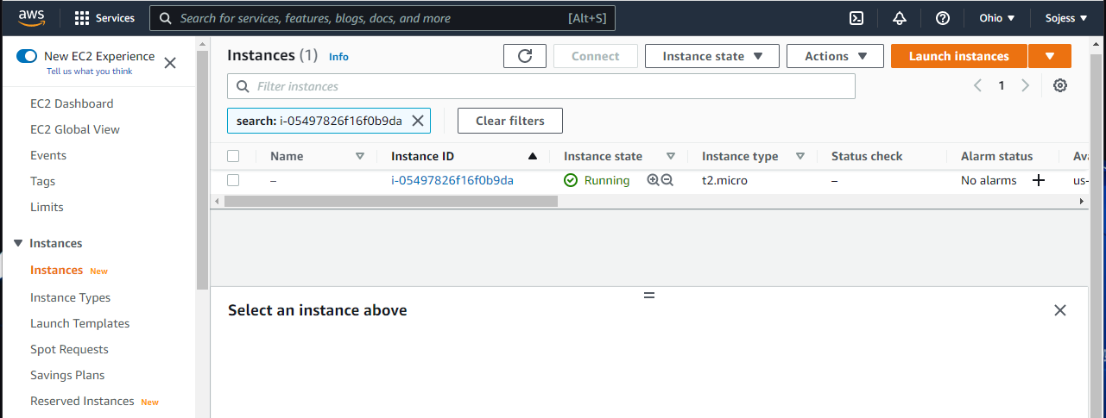

1. Open the instance by clicking on the instance id.

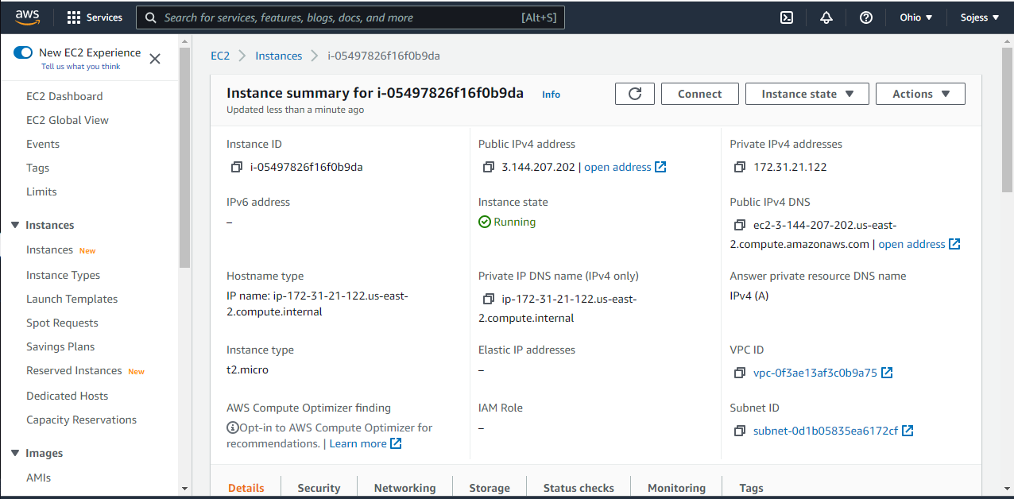

1. Click on Connect

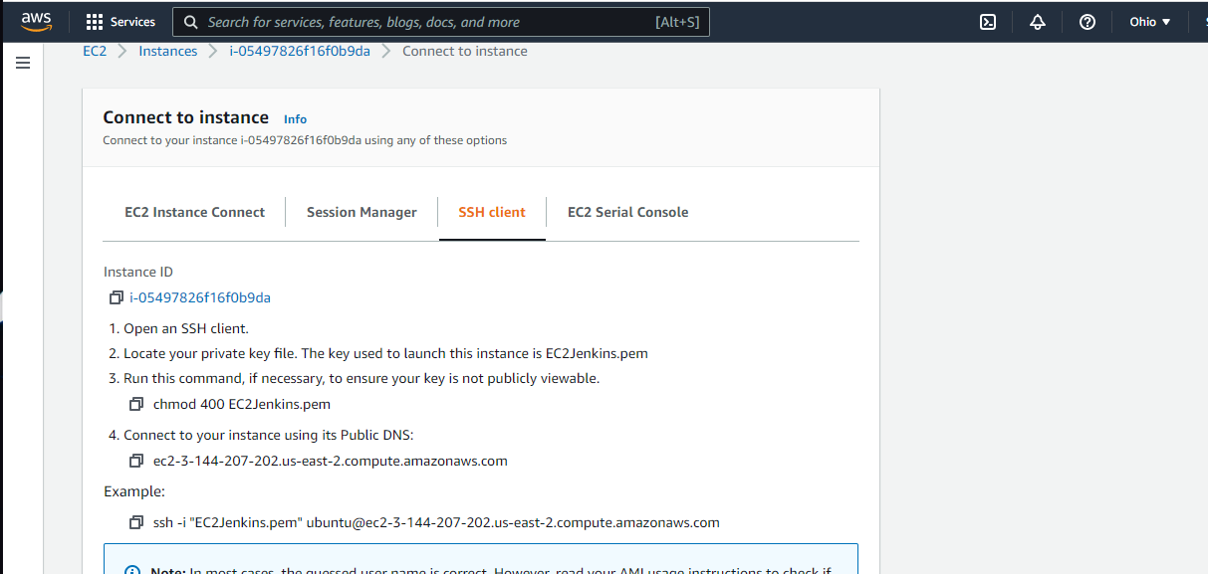

1. And Select SSH Client Tab
2. Now open your command prompt and go to the folder where you downloaded the key pair.

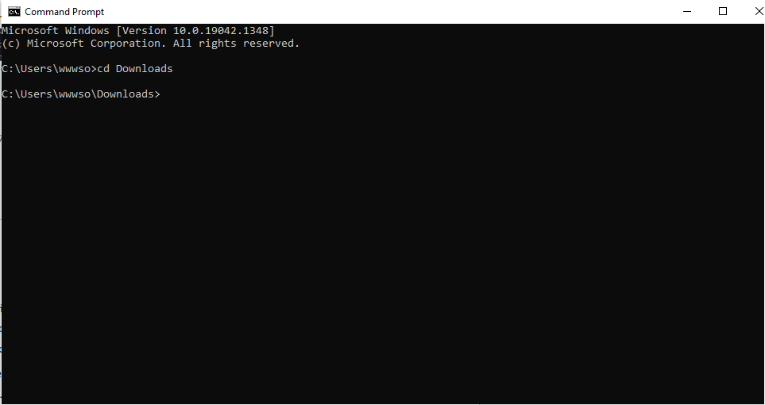

1. Copy the command similar to the one given in the below pic from the SSH Client Tab

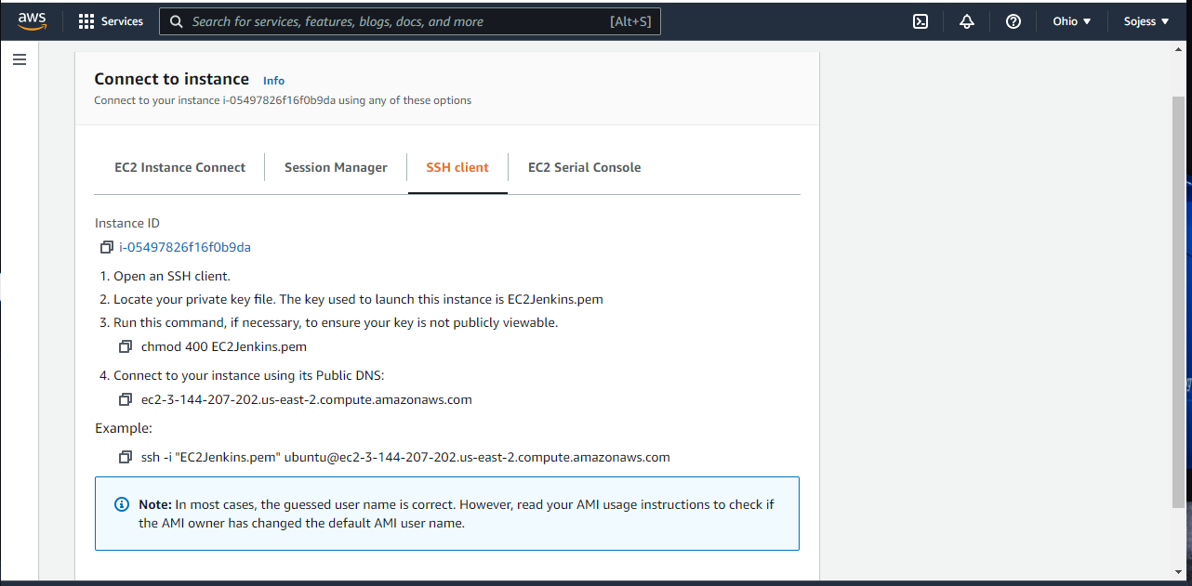

1. And paste it in the command prompt, click enter and enter “Yes” and click enter.

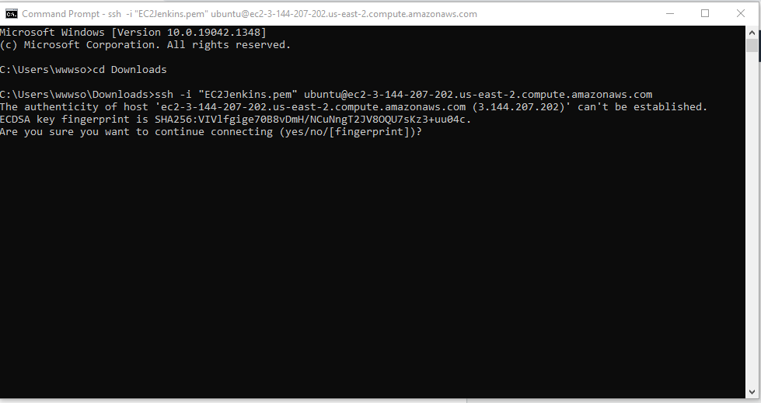

1. Now you’re successfully connected to your instance

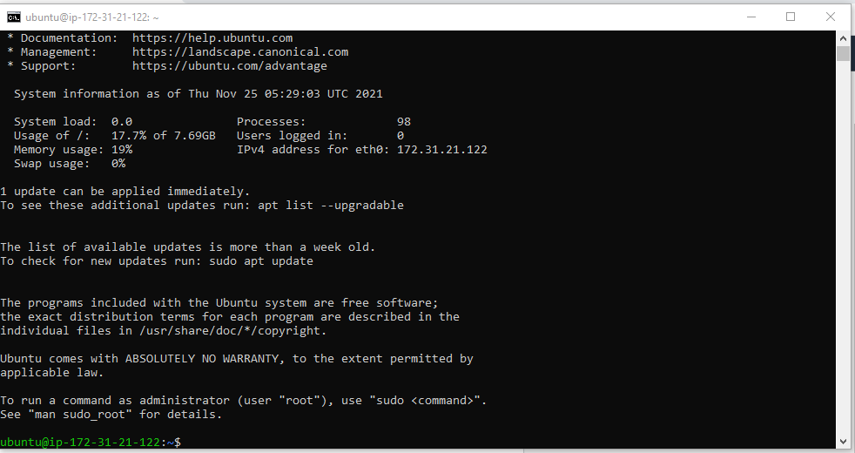

Now in order to develop the testing environment we need to install all the required package on the ubuntu server like chrome driver, chrome binary, Jenkins etc. So for that we need to get the packages updated for that

1. Run the command sudo apt-get update in the terminal
2. To upgrade all the packages that downloaded run the command sudo apt-get upgrade in the terminal. And if prompted enter “y” and

Steps to install Chrome, Git, Maven, Jenkins on Ubuntu Server

1. Install latest Chrome Binary on Ubuntu Server
   1. Run command sudo apt-get install -y libappindicator1 fonts-liberation terminal.
   2. Run command wget <https://dl.google.com/linux/direct/google-chrome-stable_current_amd64.deb> to download the chrome binary to the server.
   3. Now to run the package run command sudo dpkg -i google-chrome*.deb
   4. Now you will see some error but don’t worry run this command on the terminal sudo apt-get install -f and the error will be gone.
   5. Run google-chrome -version in the terminal to check whether the chrome binary is installed properly or not.
2. Install Chrome driver on Ubuntu Server
   1. Run command sudo apt install unzip
   2. Run command wget <https://chromedriver.storage.googleapis.com/96.0.4664.45/chromedriver_linux64.zip> . Make sure that the driver version is
   3. Run command unzip chromedriver_linux64.zip
   4. After unzipping run command sudo mv chromedriver /usr/bin/chromedriver.
   5. Verify chrome driver version by running the command chromedriver -version.
3. Install Java on Ubuntu Server
   1. Run command sudo apt-get install default-jdk. Enter y if prompted.
4. Install Maven on Ubuntu Server
   1. Run command sudo apt install maven
5. Install Git on Ubuntu Server
   1. Run command sudo apt install git
6. Install Jenkins on Ubuntu Server
   1. Run command wget -q -O - https://pkg.jenkins.io/debian-stable/jenkins.io.key | sudo apt-key add -
   2. Then run sudo sh -c 'echo deb https://pkg.jenkins.io/debian-stable binary/ > \ /etc/apt/sources.list.d/jenkins.list'
   3. Run sudo apt-get update
   4. Run sudo apt-get install Jenkins
   5. Verify if Jenkins is working by navigating to the url “youripv4 address or ipv4 dns :8080”

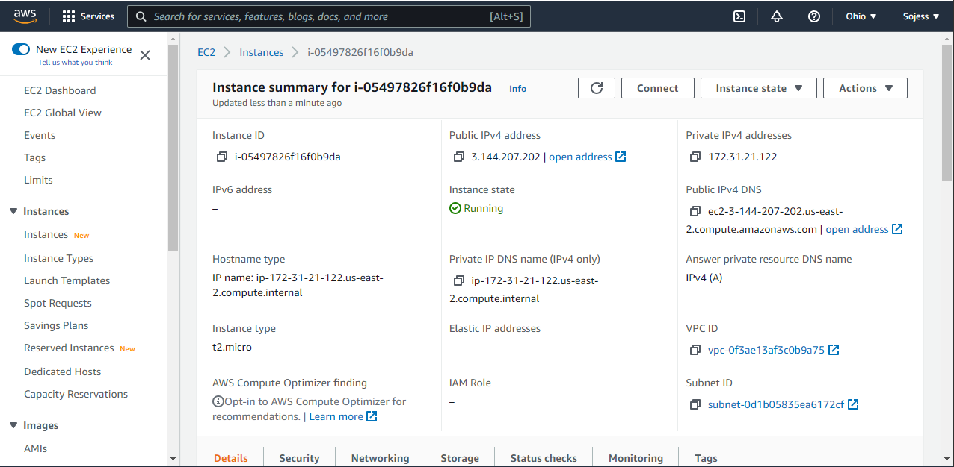

6.6 If success u will get a page like given in the below pic

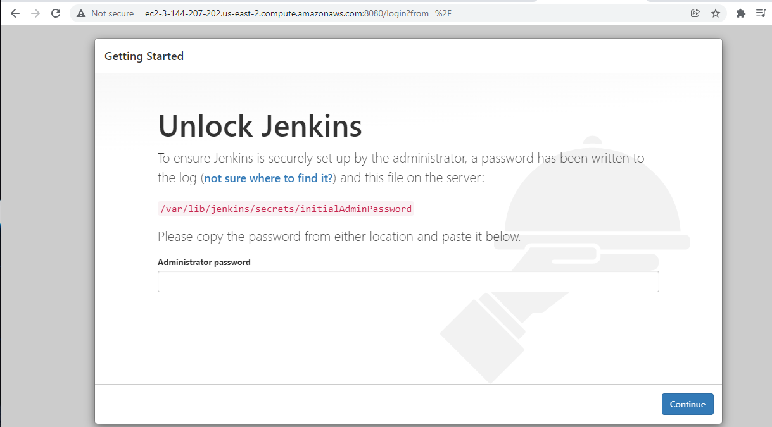

Configuring Jenkins

1. Copy the folder location given in the login page and open the terminal and run the following code sudo cat /var/lib/jenkins/secrets/initialAdminPassword
2. Copy the password obtained and paste it in the Administrator password input field. Click on continue

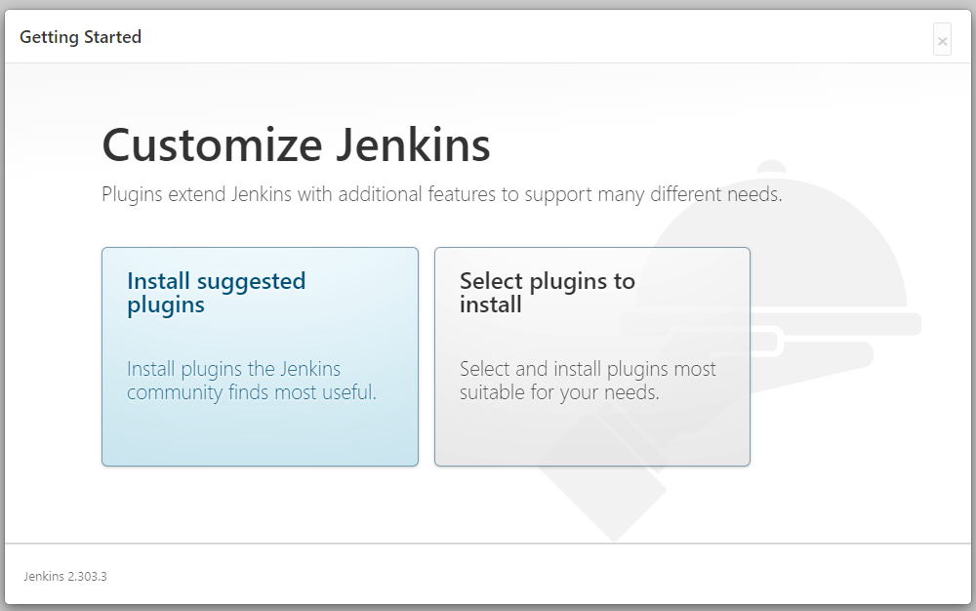

3.Select Install suggested plugins

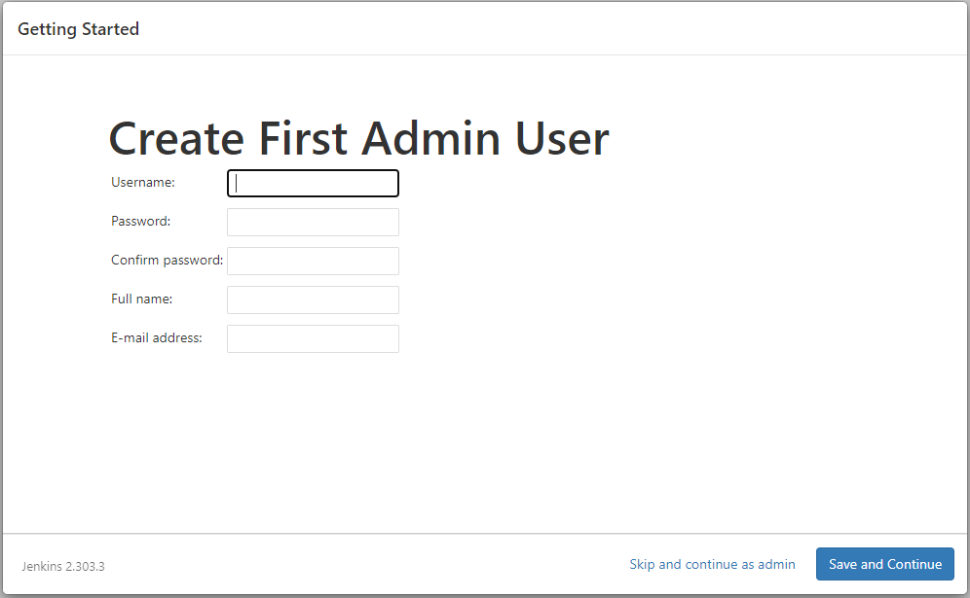

4.After the installation enter the necessary details in the following page and click on save and continue

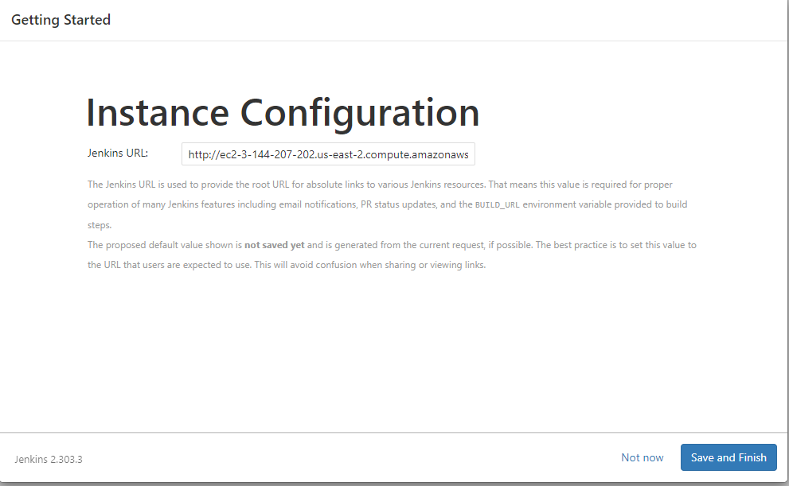

5.Click on save and finish

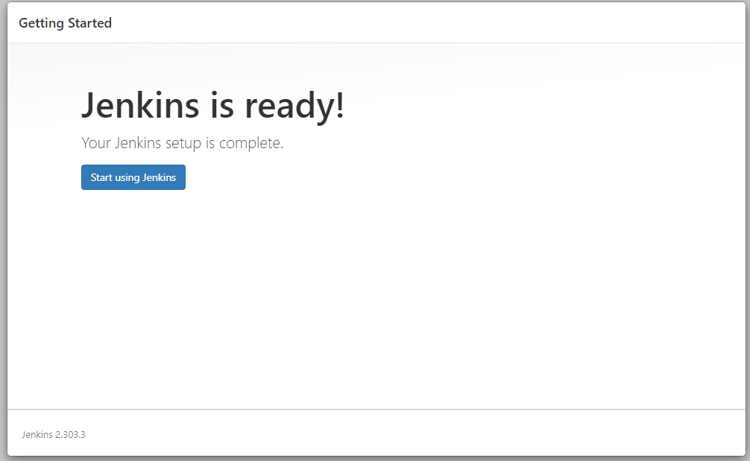

6.Click on start using Jenkins

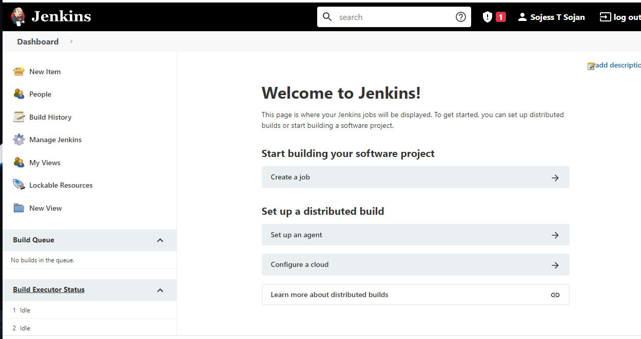

7.Select Manage Jenkins

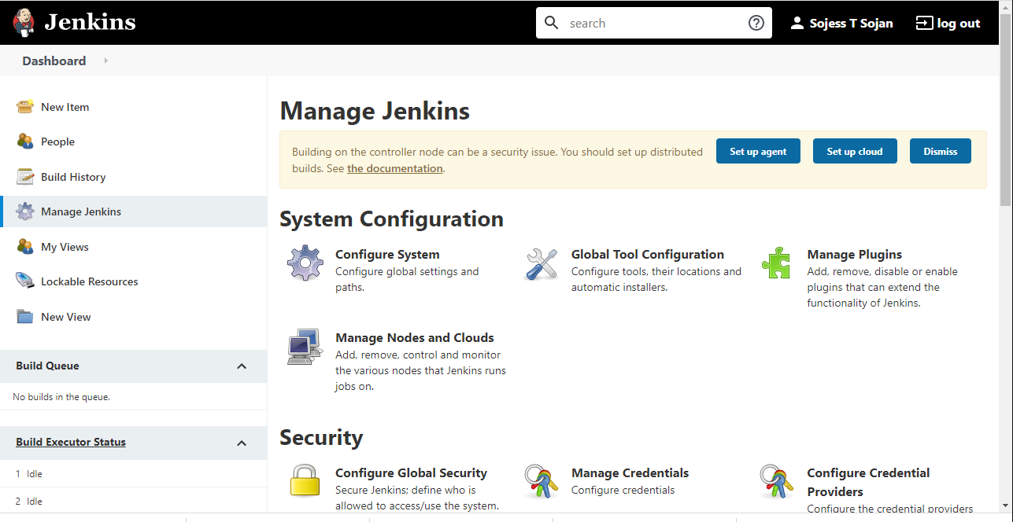

8.Select Global Tool Configuration

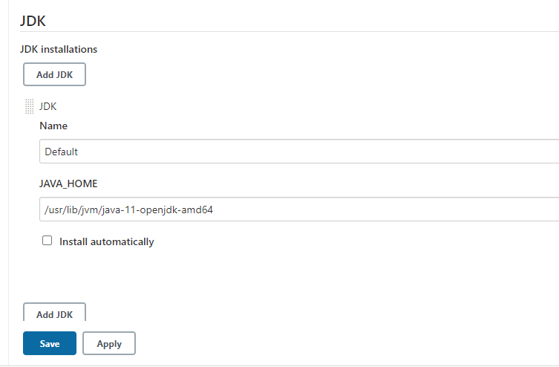

9.Scroll down to JDK section and click on Add JDK, uncheck install automatically enter Name as “Default” and in the JAVA_HOME field enter “/usr/lib/jvm/java-11-openjdk-amd64”

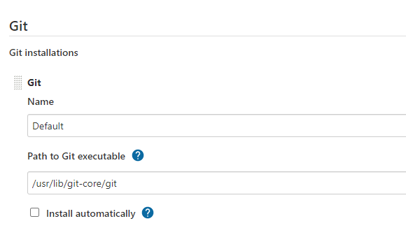

10.Similarly for git scroll down to Git section and enter the details path as “/usr/lib/git-core/git”

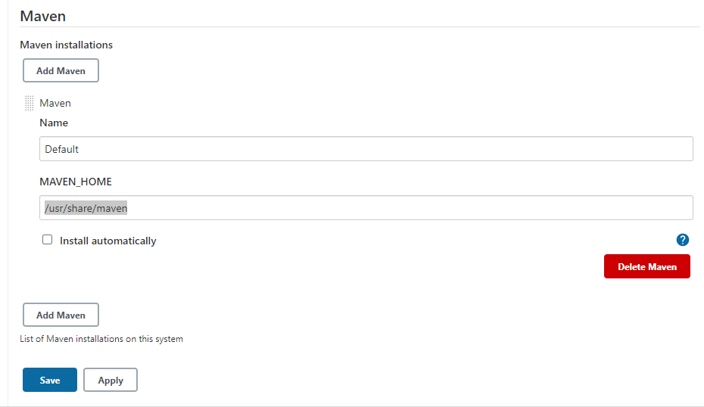

11.Likely scroll down to Maven section click on Add Maven>> Deselect Install automatically>> Add field Name as “Default” and MAVEN_HOME as “/usr/share/maven” .Click on Apply and then Save

Setting up the Build

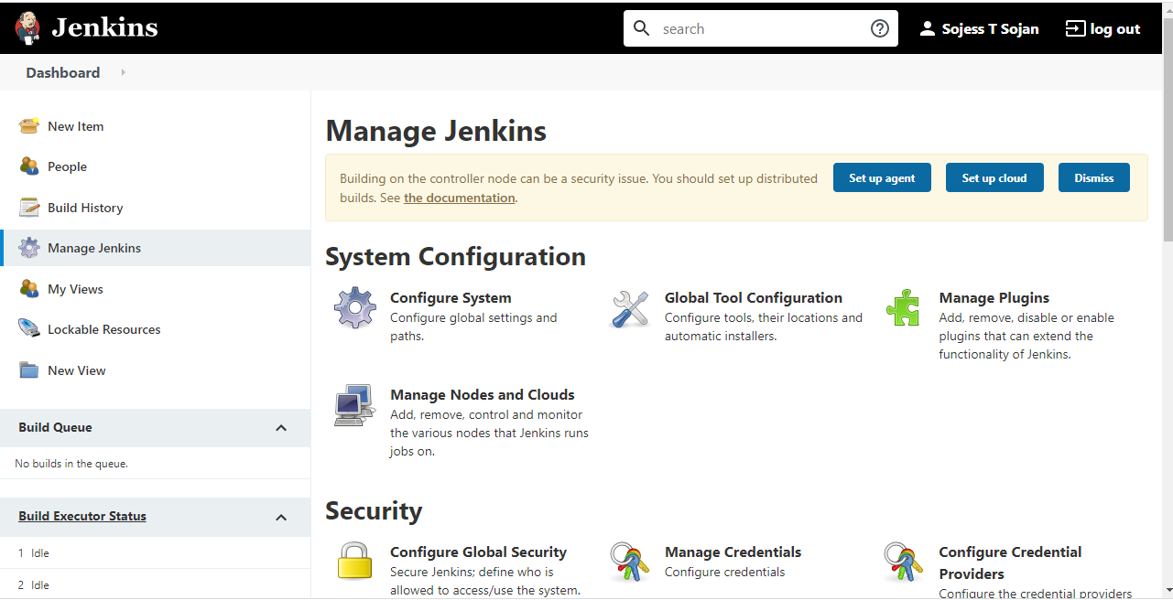

1.Select New Item

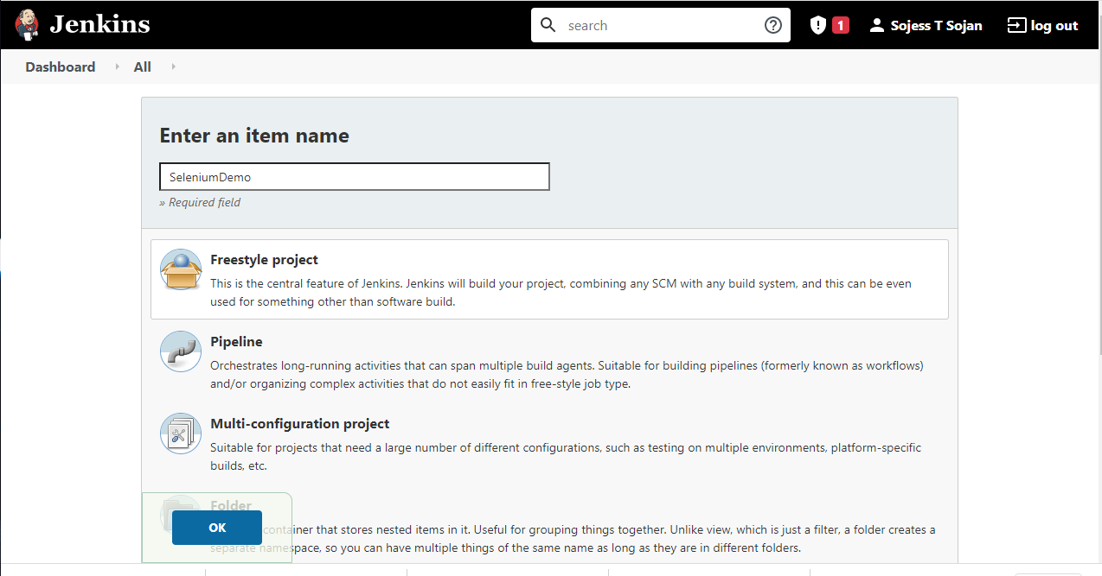

2.Enter the name and Select Freestyle project and click on ok

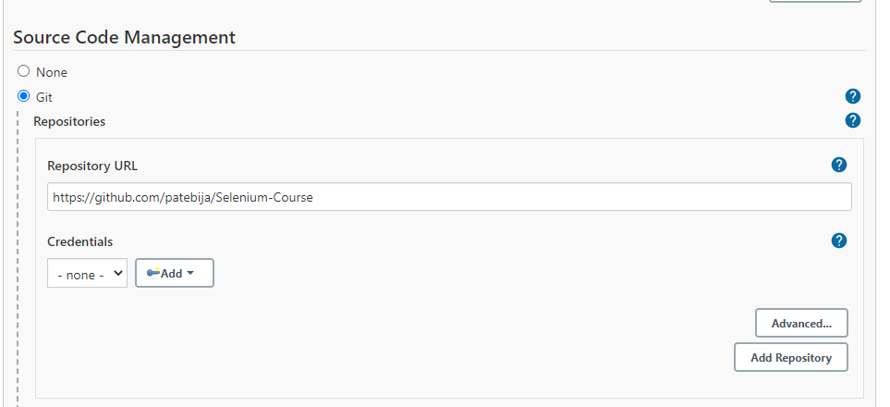

3.Scroll down to Source code management and enter the following github url in the Repository URL field <https://github.com/patebija/Selenium-Course> and click on Add.

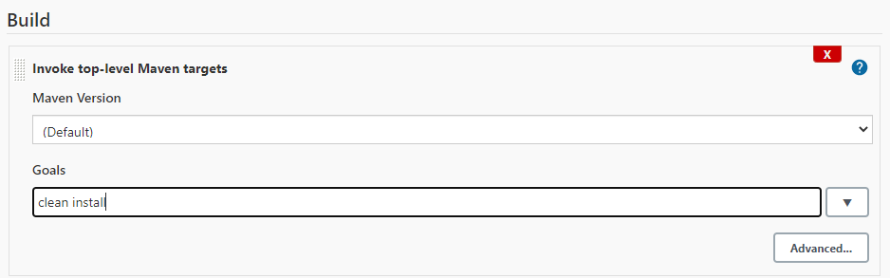

4.In the build section select build as “Invoke top-level Maven targets ” from the drop down. And fill in the fields as shown in the image. Then click on save.

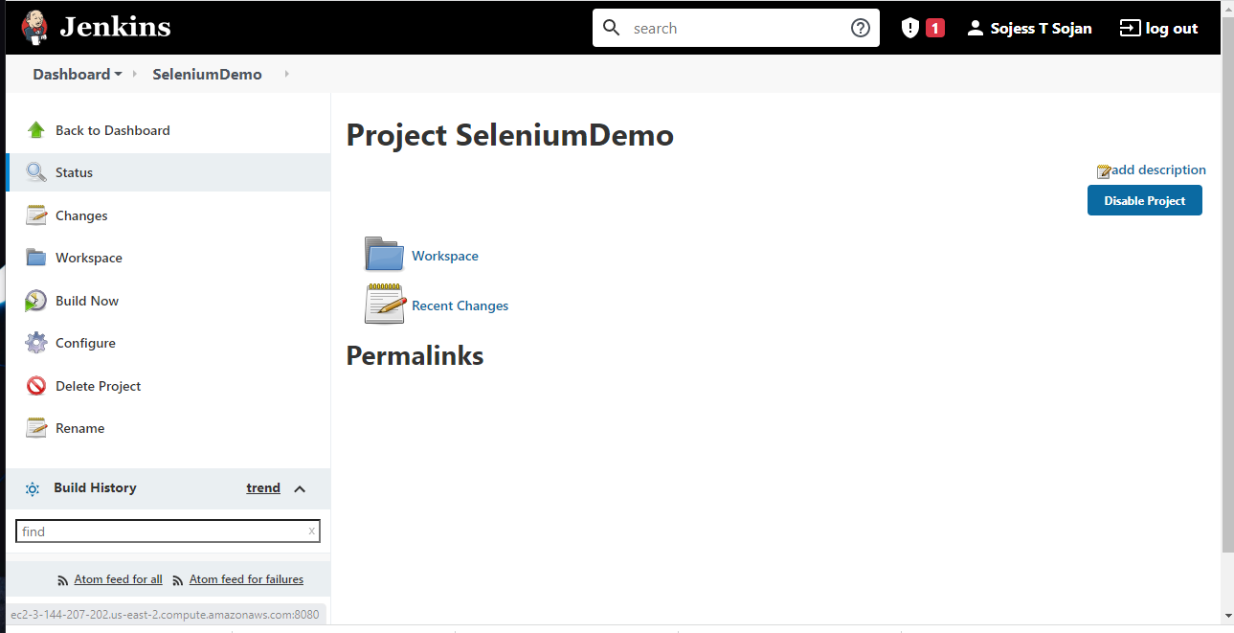

5.Click on Build Now

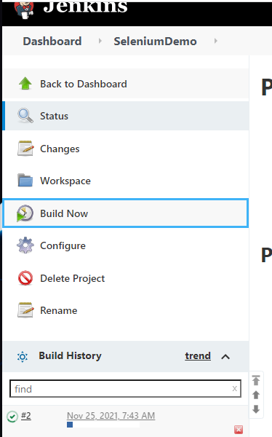

6.Click here

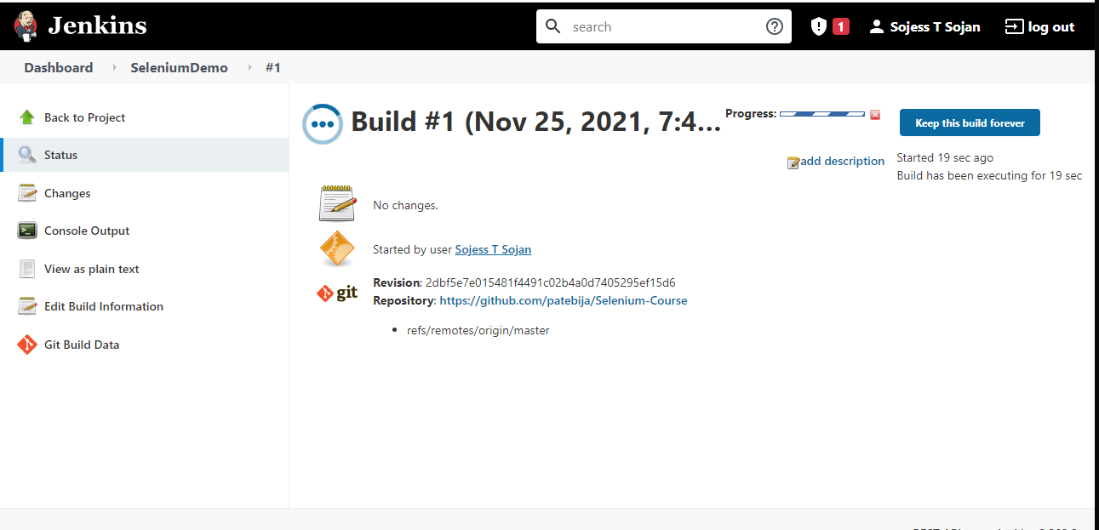

7.Click on console output

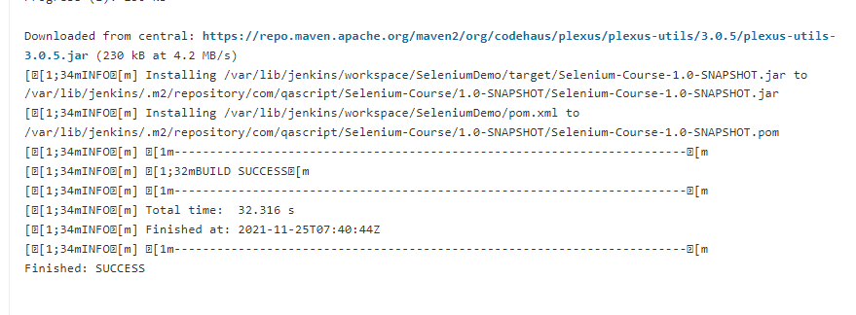

8.U will get the above output if the build is success.